Eight th task of my internship
1) Frontend Single Product Page
Create a page where a user can view the details of a single product, including:
- Product Image
- Product Title
- Price
- Description
2) Add to Cart Functionality
Add an "Add to Cart" button.
When the user clicks Add to Cart:
- The product should be added to the cart.
- The selected quantity should also be added to the cart.
- Create single_product.php
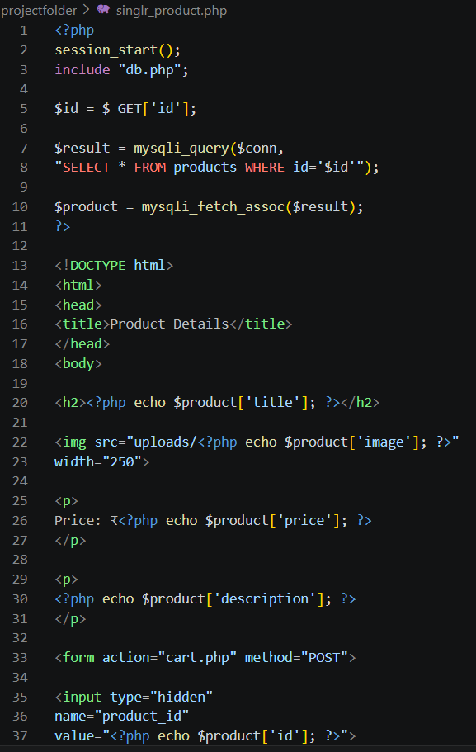
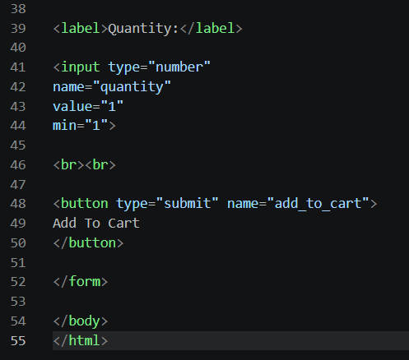
- Replace cart.php
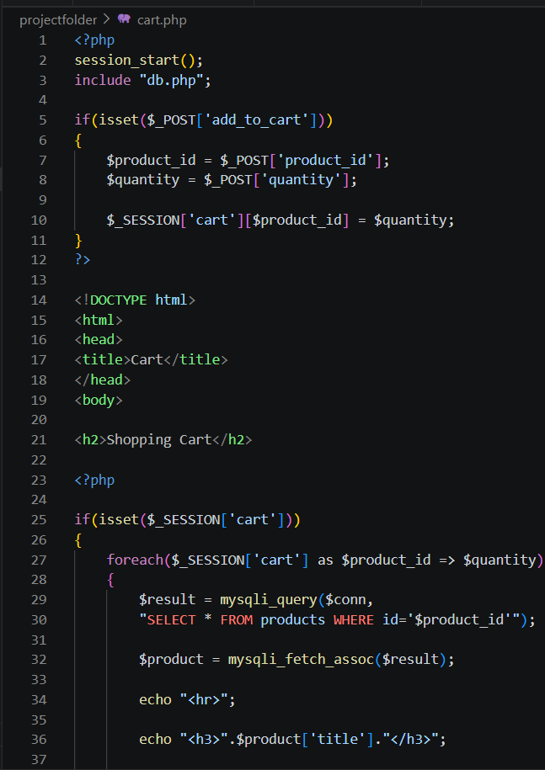
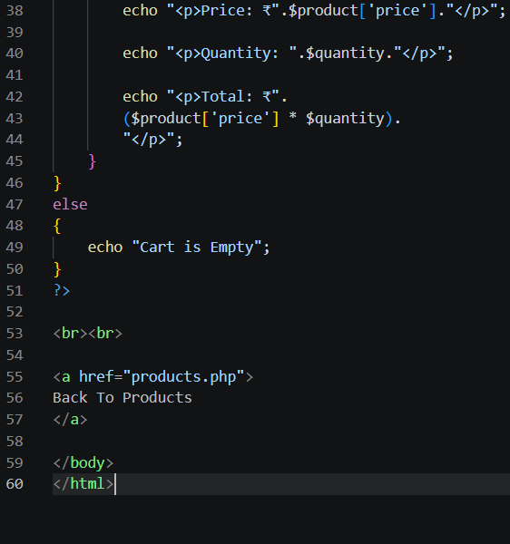
- Update products.php
Replace Add To Cart button with:
